Neal Friedman
CS 3210
Lisp Assignment 2 Test Outputs

1. sum

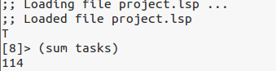

2. predecessors

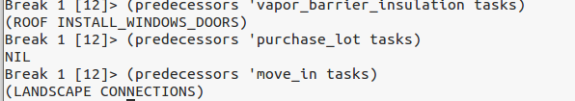
3. gettime

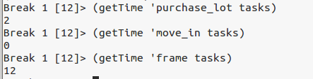

4. get_all_preds

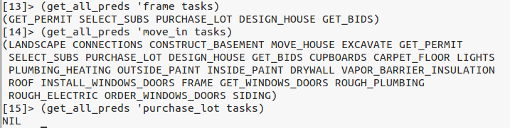

5. precedes
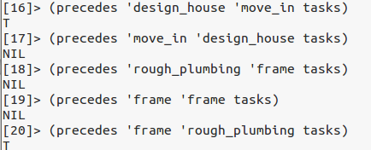

6. start_day

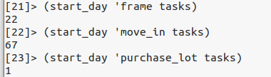

7. get_max

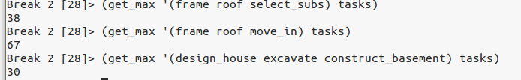

8. critical_path

** not completed **

9. depends_on

** not completed **

